BS3036, BS1362, BS 1361, BS88, BSEN60898, 61008 and 61009.

1) identify the protective device
2) How are these the same but different?
3) Which one is the odd one out and for why?

BS3036 - Rewireable fuse. Just a bit on tin.
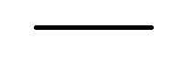

BS1362/BS1361 - fuse wire is placed into a case.



BS88 - fuse within a case and the case contains sand.



The above three fuses protect against the thermal effect. Overload is not a fault, it just means that there are too many devices plugged in.

60898 - B6 means that it requires 30 amps to trip on fault current. Whereas, B6 is the max of load. Exceed B6 is the overload.

Means that it requires 30 amps to trip, on fault current.
Whereas, B6 is the max of load. Exceed B6 will cause an overload.

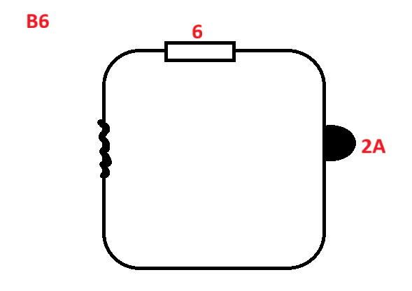
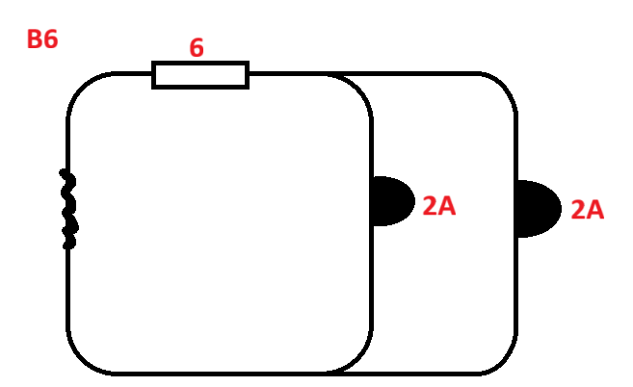

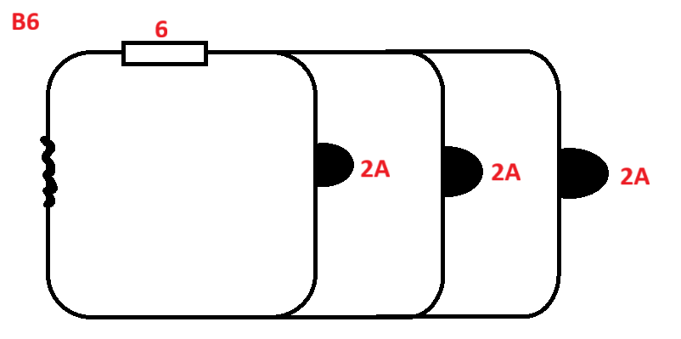

At 30 amps the magnet pushes off the fuse wire. This is because at 30 amps thermal would take too long. Whereas, with magnetism the speed is instant. Therefore, with fault we need to disconnect immediately.

61008

RCD - does not protect from overload. You connect Live and Neutral at the fuse board.Does not protect against excess current. Does not protect the cable.

Live to Neutral → is called a short-circuit
Live to Earth → Earth fault

Circuit breaker

- Overload B6
- Fault protection 30 amps (6x5)

RCD
- Fault protection
- Additional protection

Overload  BS3036 | Overload  BS1361 | Overload  BS88
Overload  BSEN60898 | 61008 | Overload  61009

RCBO = 60898 + 61008

TNS

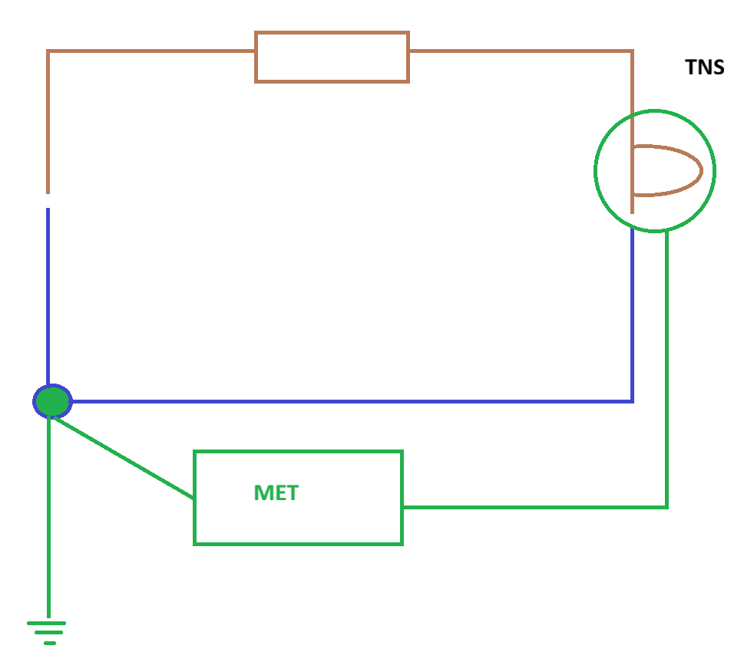

TT

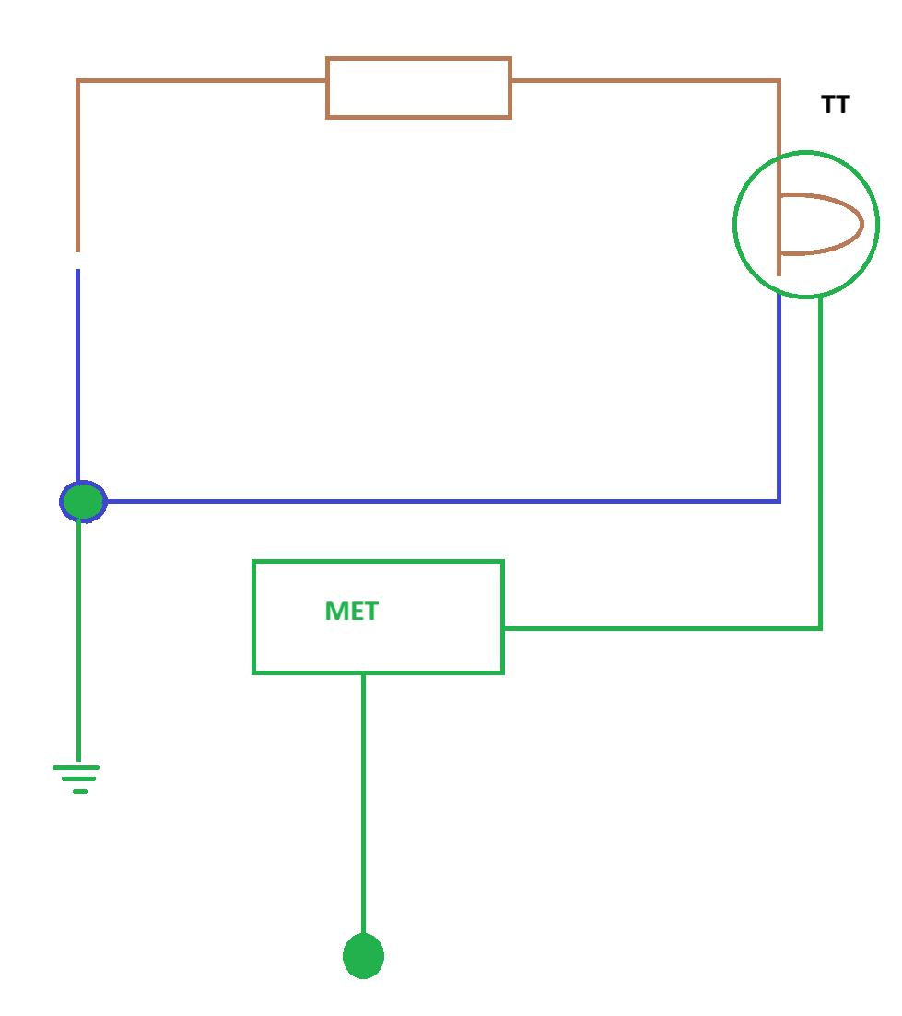

TNC-S

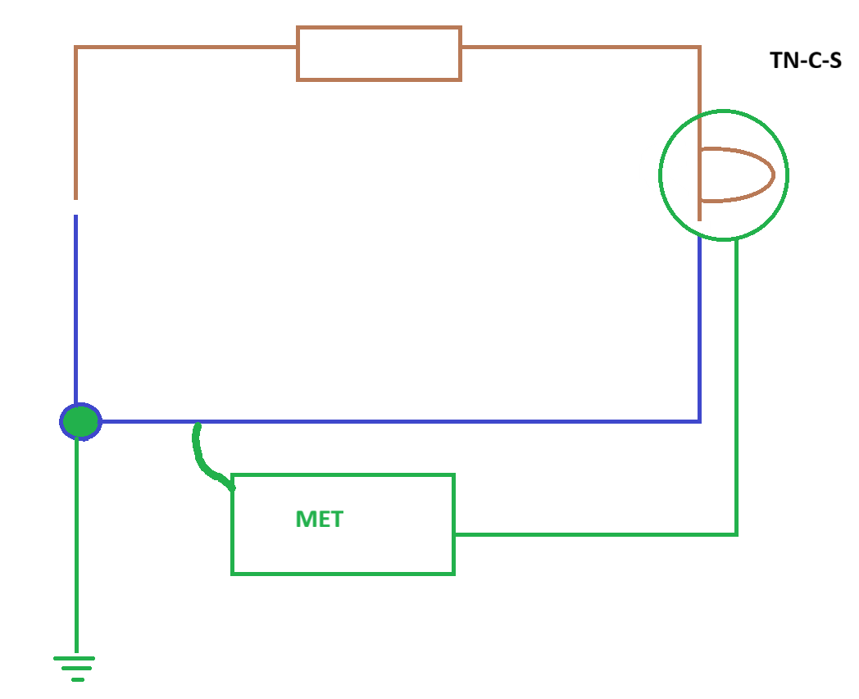

An excess of current - Overload, Fault current

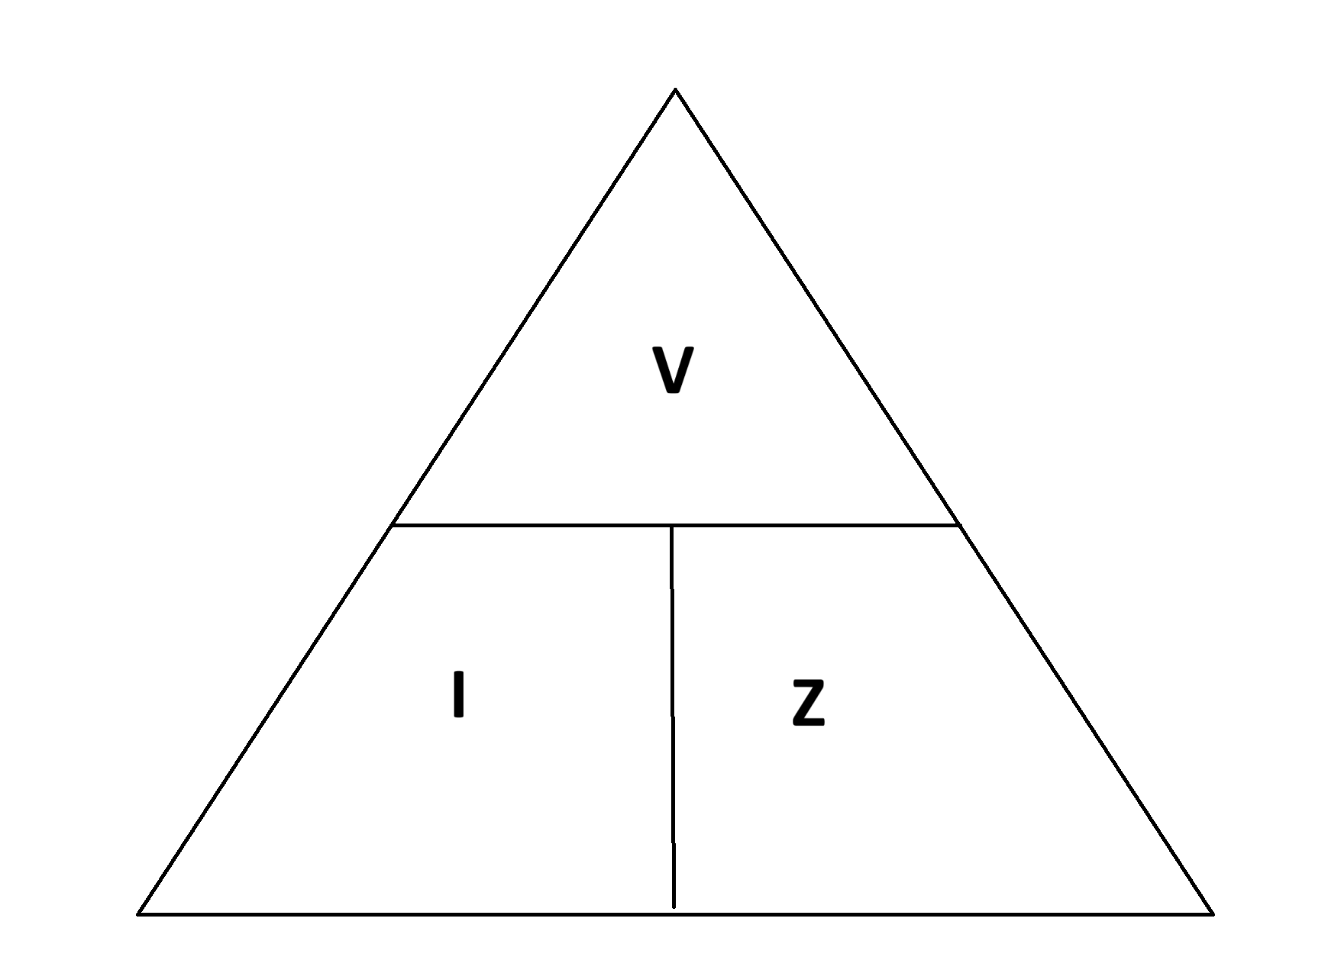

C min 0.95

218.5
= 7.28Ω max permitted
= max measured 80%
5.83

There is overload, fault and additional protection.

100 milliamps for the main switch

Ohms = means the opposition to current flow.

Z Ω
R Ω

